# **Computer Hardware Identification**

**Date:**

**Group Name:**

**Group Members (2 Max):**

In this activity, in groups of 2, you will be taking a computer apart. Using a working computer and a phone, take pictures of the components and enter a description of the component and what it does. If the computer that is being dissected does not have the component, then getting an image from the internet is acceptable. Identify and describe the following computer components:

1. 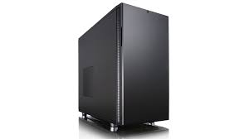Case

Usually black or grey.

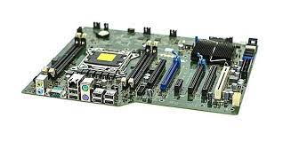 The case houses all the interior components.

1. Motherboard

A thin green board of technology.

This functions as a base for most interior components to link up with each other.

1. CPU

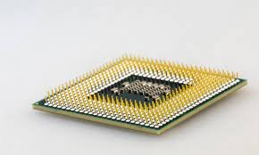A small grey square inlaid with gold pins.

This small grey square control all of the processing and does more for the PC than all the remaining components.

1. GPU

A large rectangle usually grey and has fans.

This piece of hardware controls the graphics of

1. RAM

A thin green stick covered in black chips.

This stick determines how much tempory information the PC can have

1. A close-up of a touch screen device

   Description automatically generated with low confidenceStorage Device
2. Cooling
   * A picture containing text, hard disc, electronics

     Description automatically generatedCPU
     1. Image:
     2. Description:
     3. Function:
   * Chassis
     1. Image:
     2. Description:
     3. Function:
3. PSU (Power Supply Unit)
   * Image:
   * Description:
   * Function:
4. Monitor
   * Image:
   * Description:
   * Function:
5. Mouse
   * Image:
   * Description:
   * Function:
6. Keyboard
   * Image:
   * Description:
   * Function: